# Week 6: Introduction to Product Design - Product Design Within Teams

Note that this is the **individual** version.

|  |  |
| --- | --- |
| **Concepts** | * Starting Bluetooth Speaker project * Creating teams * Using derived parts * Organizing the Feature Tree * Simultaneous collaboration (i.e. “Google Docs-style collaboration) * Including comments * Following |
| **Models** | * Bluetooth Speaker with Speakers, Frame, Front Cover, Battery Compartment, and Button Overlay |
|  | |

# 

# 

# Bluetooth Speaker Overview

In product development, collaboration is critical to planning and executing a successful design project. Luckily, Onshape supports collaboration in ways that were never before available in the CAD world. This week, we will begin using these collaboration tools to work on a team-designed bluetooth speaker.

Over the next few weeks, we will build the Bluetooth speaker below, and focus on how to complete a larger design project within a team. We will learn about some of the unique collaboration tools within Onshape, as well as walk through a true Top-Down design process.

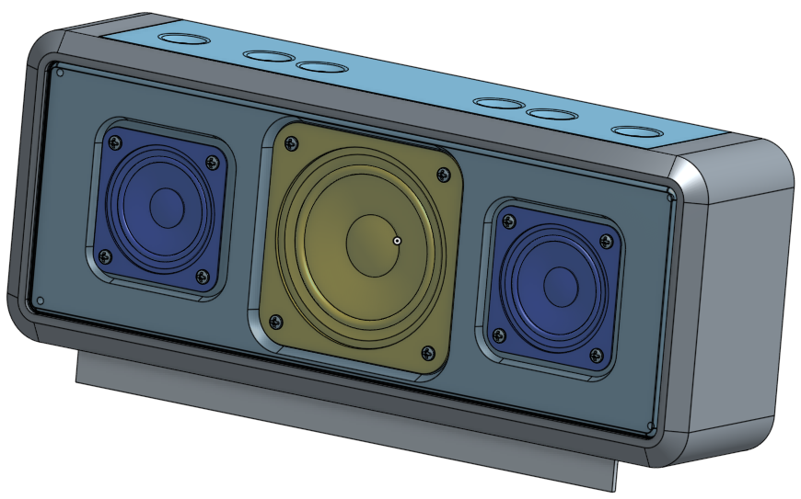

## Teams

One of the unique ways to collaborate within Onshape is to create a Team. Documents can be quickly and easily shared among many individuals who are a part of the team, and members of a team do not need to have anything in common, not even a specific Onshape plan. In order to prepare for this Bluetooth Speaker project, let’s first create a team between you and someone else (a partner, your instructor, or a second account):

1. From the Onshape Documents screen, click on your profile name in the upper-right corner, and select Manage Account:

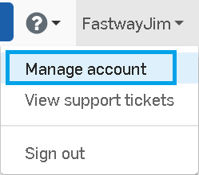

1. Select Teams from the menu on the left, and then select the  button. Fill out the quick form (Team name, and optional description), and then select the Create Team button again:

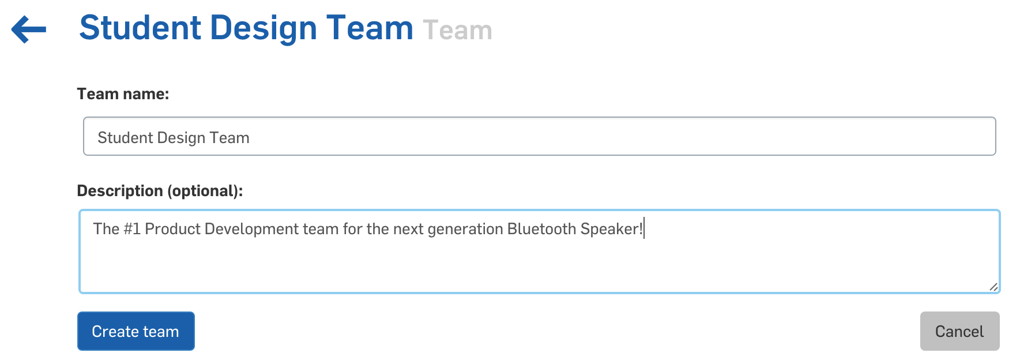

1. Now, add several members to the team. When complete, just click on the back arrow in the top left, highlighted below:

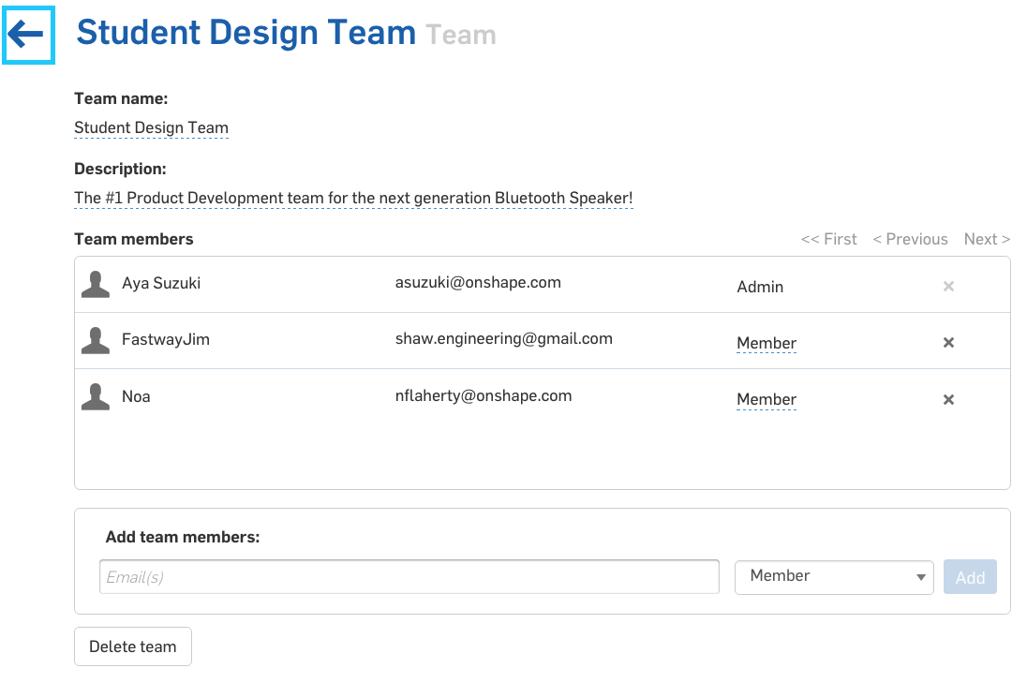

*Pro Tip: People do not have to have an Onshape account to be added to a team. Onshape will automatically send them an email invitation to create an account. When they are added to the team, they will get an email icon as shown above for* [*student@college.com*](mailto:student@college.com)*. Once they create an account, the icon will change as shown with the other members of the team above. For more information on how to create and manage teams, go to the the Onshape help:* [*https://cad.onshape.com/help/#organizations.htm*](https://cad.onshape.com/help/#organizations.htm)*.*

1. Next, go back to the documents page, and create a new, private, document, called “Bluetooth Speaker”:

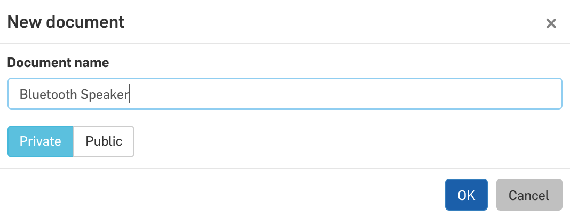

1. Now, from within the document, click on the Share button in the upper-right corner, and share the document with your team. Note, that there are many different ways to give access to the document. Your instructor will tell you what type of access they will like to get. Click Close when complete:

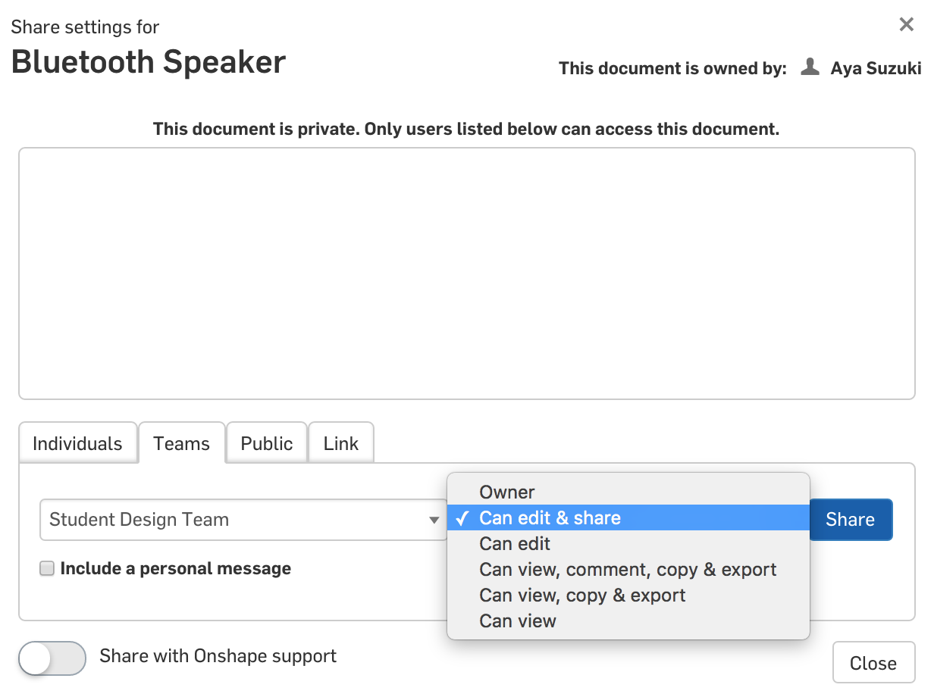

## Derived Parts

Now that the document is shared, we can focus on creating geometry. Previously, in Week 3, we discussed Top-Down Design, and the benefits of how Top-Down Design is made easy by multi-part Part Studios. With our Bluetooth Speaker, we are now going to see the power and benefits of utilizing Top-Down design first hand. However, before we begin designing our speaker enclosure, we must consider what the best design intent is. What drives the enclosure? The speakers, of course! If we bring our speakers into the Part Studio, we can design the rest of the speaker enclosure around them. To do this, we will need to use "Derived Parts."

A Derived Feature is one where a part, sketch, surface, helix, plane, or mate connector from one Part Studio (called the “parent”) is inserted into another through an associative link. When this occurs, the Derived Feature is permanently linked to the parent, and any changes to the parent will automatically get transferred to the derived feature. More information on Derived Features can be found in the Onshape Help: <https://cad.onshape.com/help/#derived.htm>

With our Bluetooth Speaker, we are going to design a frame and speaker housing assembly around speakers that are already designed. This is quite common, where a Bluetooth Speaker company would not design the actual speakers themselves, but rather purchase existing speakers from a supplier, and then design everything else around them.

1. First, let’s import the speaker models. From the bottom of the screen, we will create a new tab, by selecting Import:

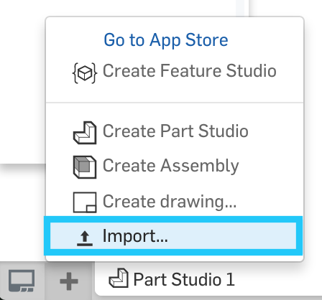

1. Browse to the “Speaker_large.STEP” file, and click OK. At the next screen you do not need to select either option, just select “OK”:

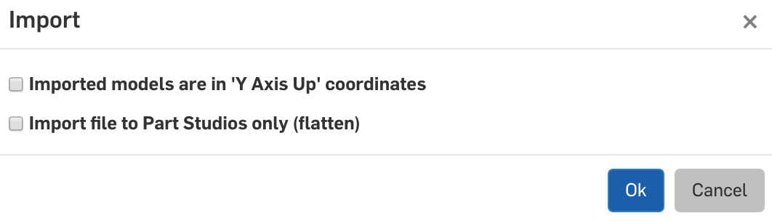

1. After the import, you will notice two new tabs at the bottom, “Speaker_Large.STEP” and “Speaker_Large”. The first tab is the file itself and can be downloaded later if need.The second tab is the actual geometry, which is now converted into an Onshape Part Studio. In the top right there are also a few informational messages.

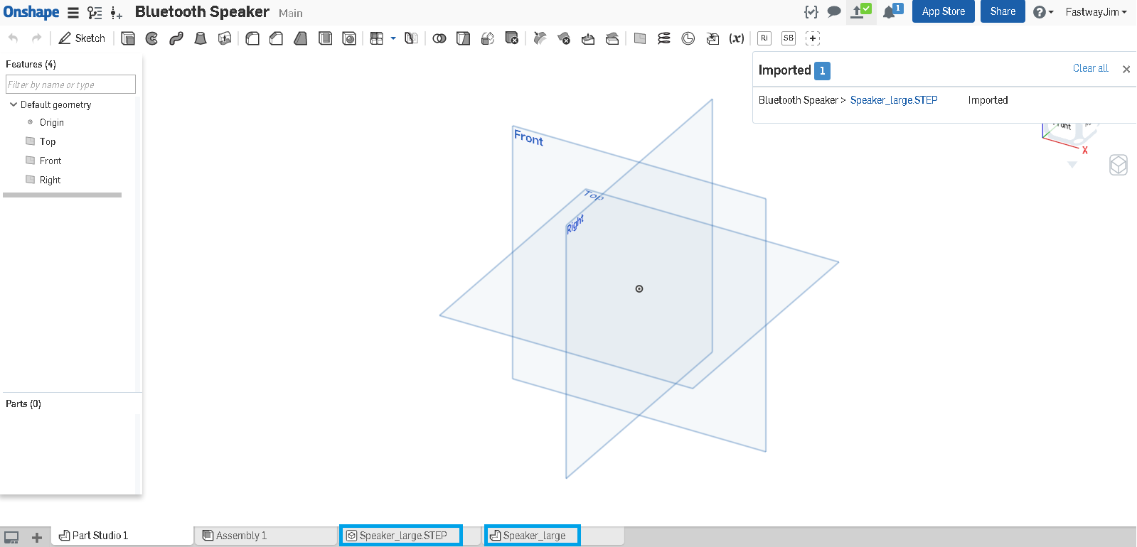

1. Let’s delete the step file tab by right clicking, then Delete. We won’t be needing the original file. We should now have a single, new tab, that shows the imported speaker geometry:

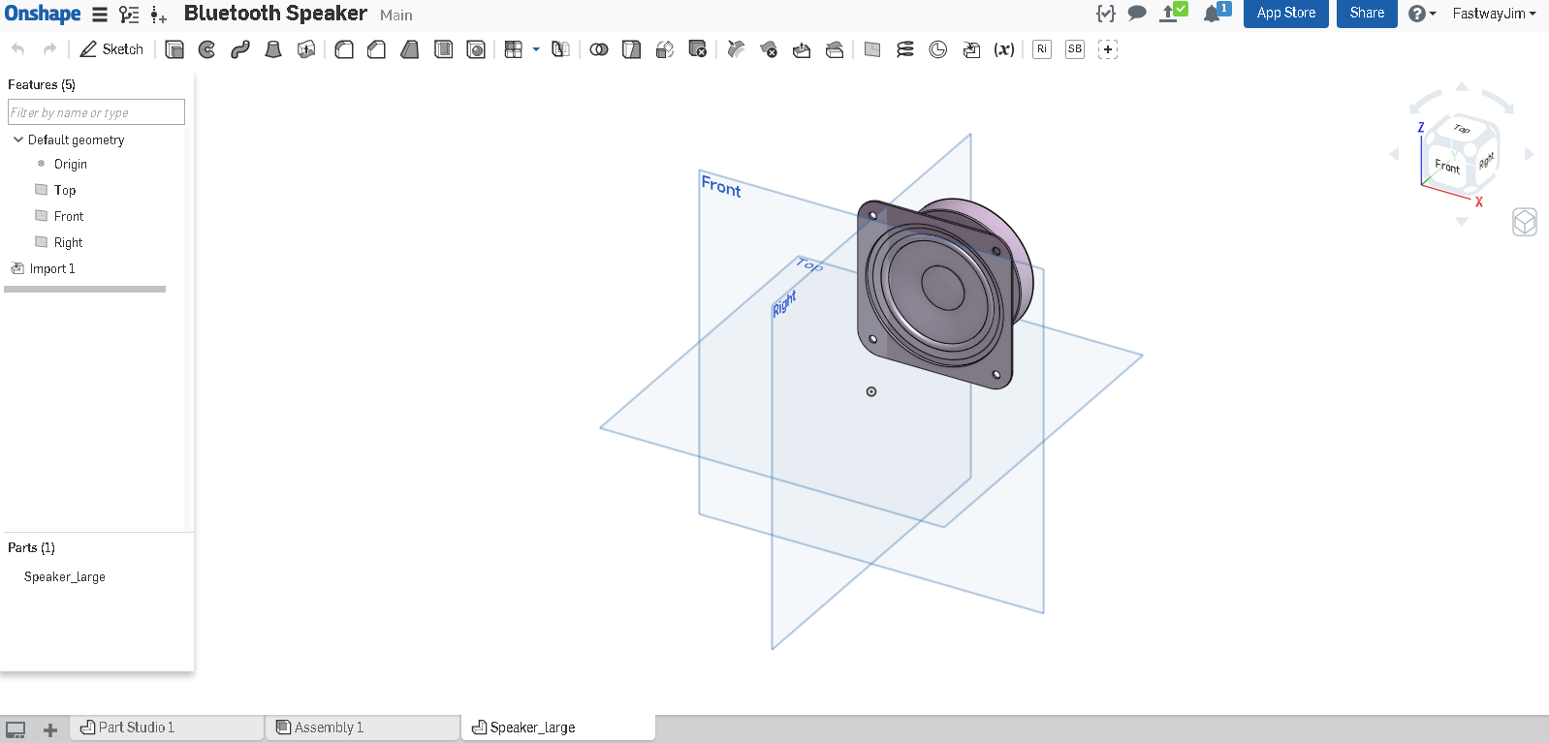

1. Let’s repeat the process with the small speaker:

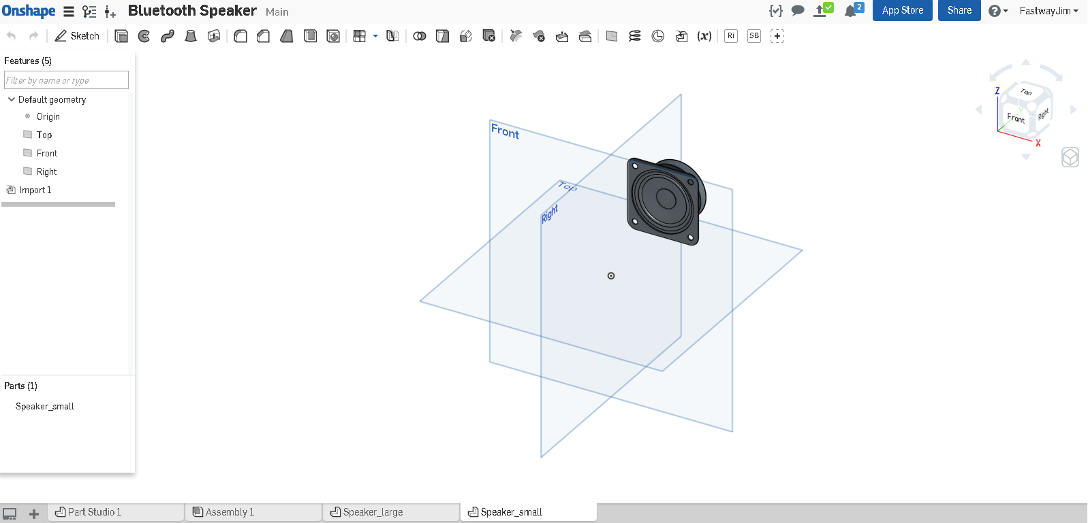

1. With our speaker models imported, let’s navigate to our original Part Studio 1, and create our Derived Part features. This will bring the two speakers together into a single Part Studio. Select the Derived icon  in the toolbar. We are now given a dialog:

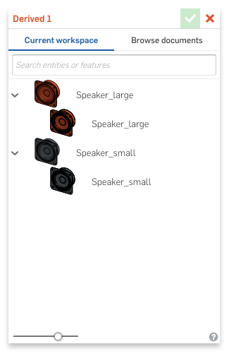

*Pro Tip: Note how the dialog also allows us to “Browse” for documents as well. This can be very helpful when there are already existing parts in Onshape that are either created by you, shared with you by someone else (such as via an Onshape Team), or out in the public space. For this design, we have decided to show how to import existing CAD models (via IGES, STEP, or Solidworks file types).*

1. Let’s select the Large Speaker first, and then select the green checkmark:

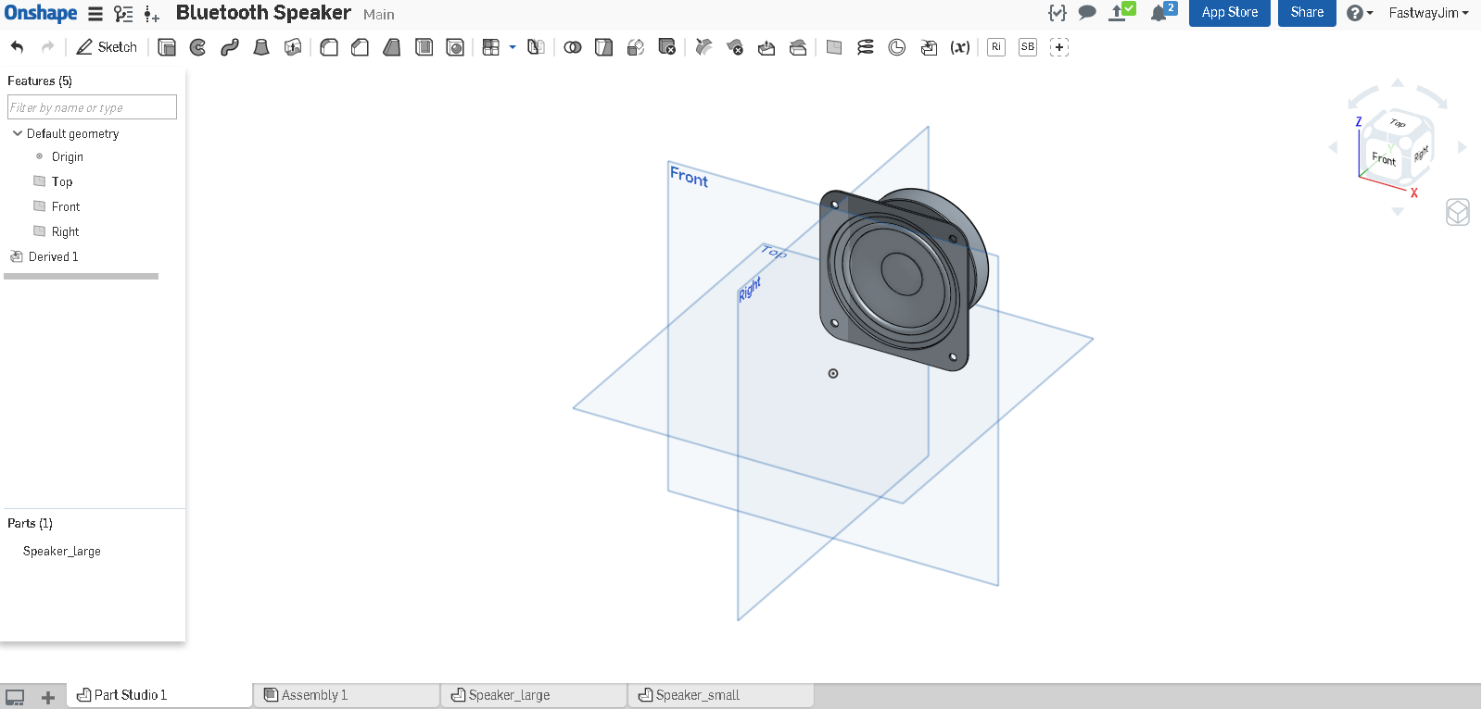

1. Notice how the speaker is not yet in the middle of our model. We know that the large speaker is in the center of the speaker enclosure, so it is best practice to move it there. Let’s move it using the Transform tool . Select “Translate by XYZ” from the dropdown menu. Using the following values, the speaker should now be centered:

|  |  |
| --- | --- |
| Transform 1 (Large Speaker) | |
| X Translation | -0.8327 in |
| Y Translation | -1.2500 in |
| Z Translation | -1.6872 in |

1. Next, let’s import the small speaker, using the derived feature again, and this time selecting the small speaker:

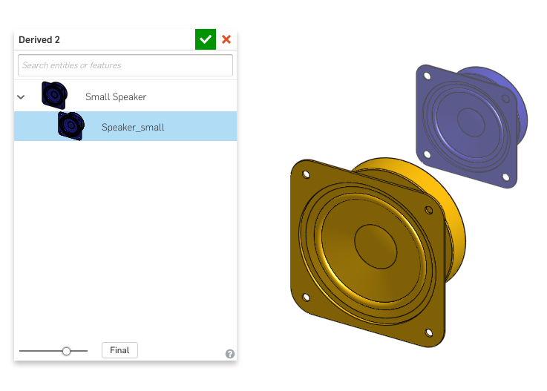

1. Now, let’s now transform the small speaker to move it into its proper position, using the following XYZ Translations:

|  |  |
| --- | --- |
| Transform 2 (Small Speaker) | |
| X Translation | -3.5827 in |
| Y Translation | -1.58802 in |
| Z Translation | -1.6872 in |

1. The speakers should now be next to each other like this:

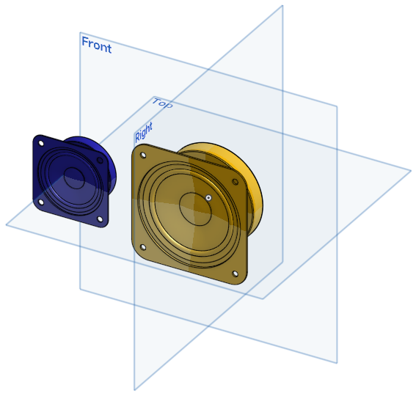

1. WIth the speakers in place, let’s create the housing geometry. Start by hiding the speakers so it is easier to sketch, and then create the following sketch on the Front Plane. Make sure that the sketch is defined as below, using the proper combination of dimensions, and constraints. The corners are made with sketch fillets, and the large circle is at the origin, with the rectangle centered around it. The outer edges of the housing and the small circle are blue because they have not been located yet. That is okay for now:

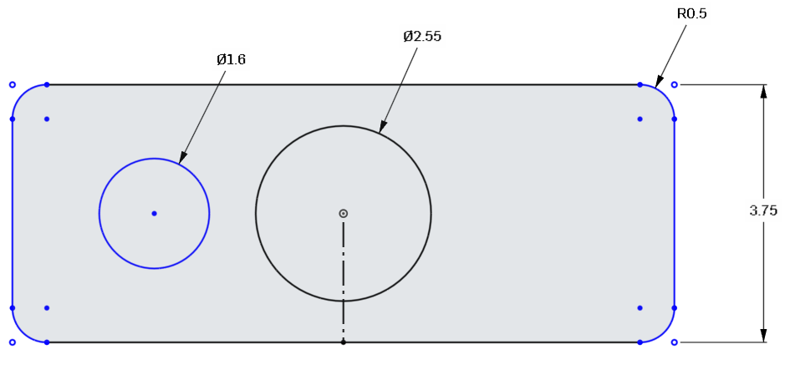

1. Now, let’s constrain the small circle using the small speaker. To do this, unhide the speaker, and then use one of the circle edges on the speaker to create a concentric  constraint with the sketched circle. It should now be fully defined and turn black:

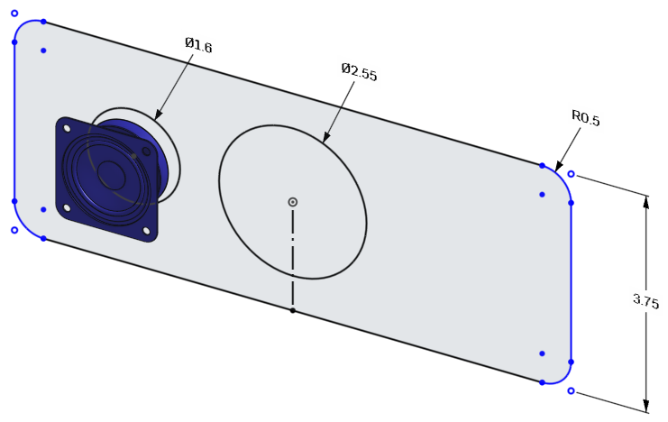

1. Next, add a dimension between the small circle and the outside edge of the housing (the small speaker has been removed for clarity):

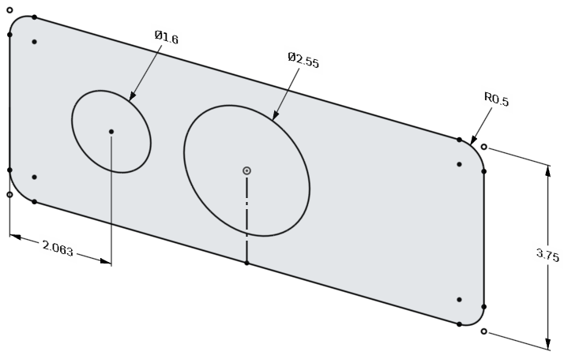

1. Next, since the part is symmetric, we can now use the vertical construction line to mirror the small circle over to the right. Start by selecting the Mirror tool, . You will then be prompted by Onshape to select the sketch line to use for the mirror: . Select the vertical construction line:

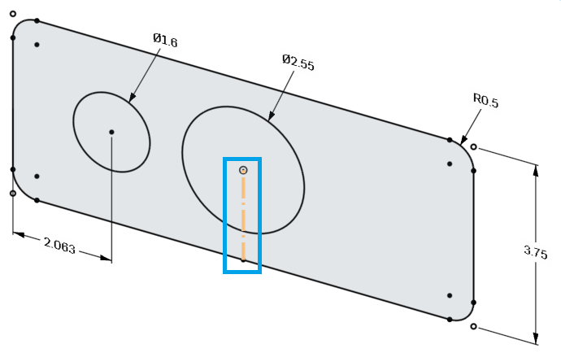

1. Next, you will be prompted by Onshape to select the geometry to be mirrored: . Select the small circle:

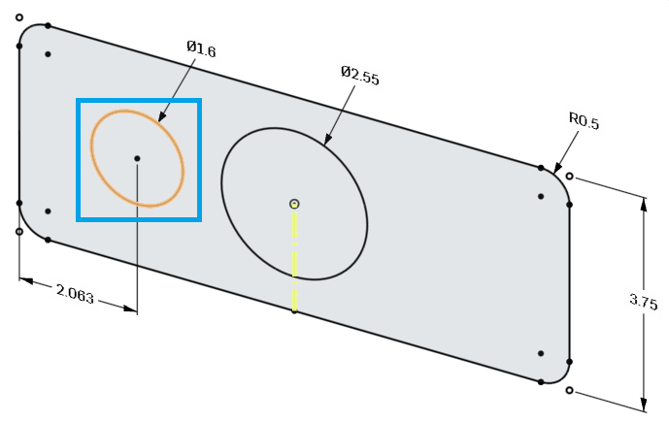

1. The sketch should now have two small circles, symmetrically located around the center of the housing:

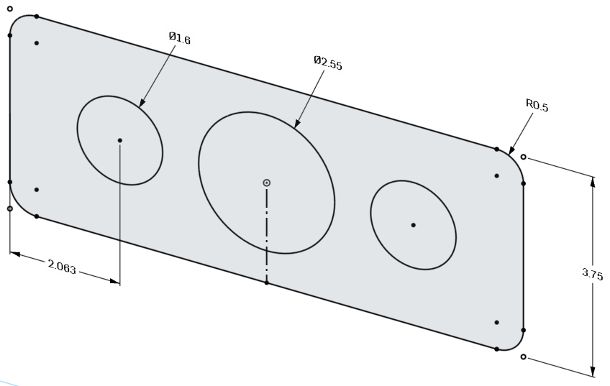

*Pro Tip: Let’s reflect for a moment. We just created a sketch for the housing of our bluetooth speaker, which contains the outer rectangular geometry, and the inner hole geometry. However, we did not dimension the holes for the speaker, they are actually located by the speaker itself! This means, if we move the small speaker, the hole will move with it! We have made a smart CAD model that allows us to easily experiment with different sized speaker enclosures. We are not going to test this functionality quite yet, but we will later on. This concept, using existing parts to drive sketch geometry, is the most direct application of “top-down design”.*

|  |
| --- |
| **Design Intent Check**: In each **Design Intent Check**, we’re going to be referencing the final Bluetooth Speaker to see what part we’ll be making next. First, we’re going to be making the main Frame of the speaker, highlighted below. How do the front details of the Frame relate to the positions of the speakers? |

1. Next, let’s extrude the entire sketch, holes and all, 2” deep symmetrical about the Front Plane. This should be a new part, and the small speaker may be hidden for clarity. The name of the new part is Frame:

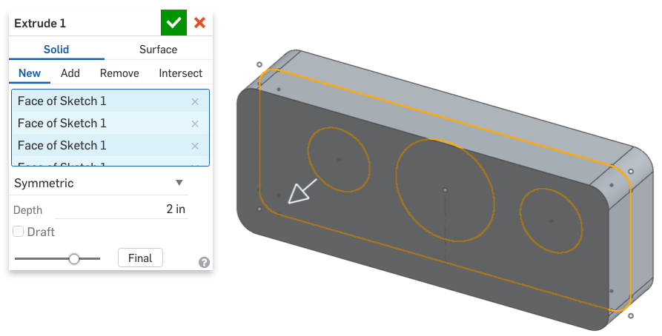

1. Next, let’s add a step to the front face of our Frame. Create the following sketch, using the Offset tool . Click on the tool, then select the outer perimeter of the frame and press enter. Type in the following dimension:

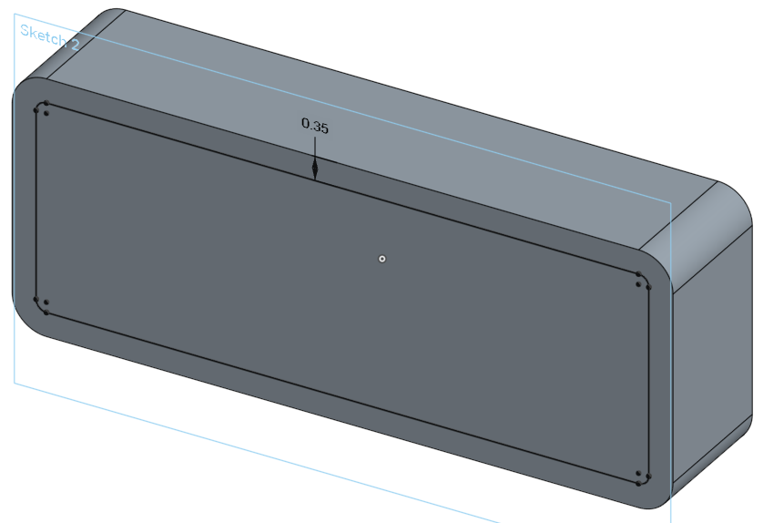

1. And let’s extrude it 0.1” into the part, and remove material:

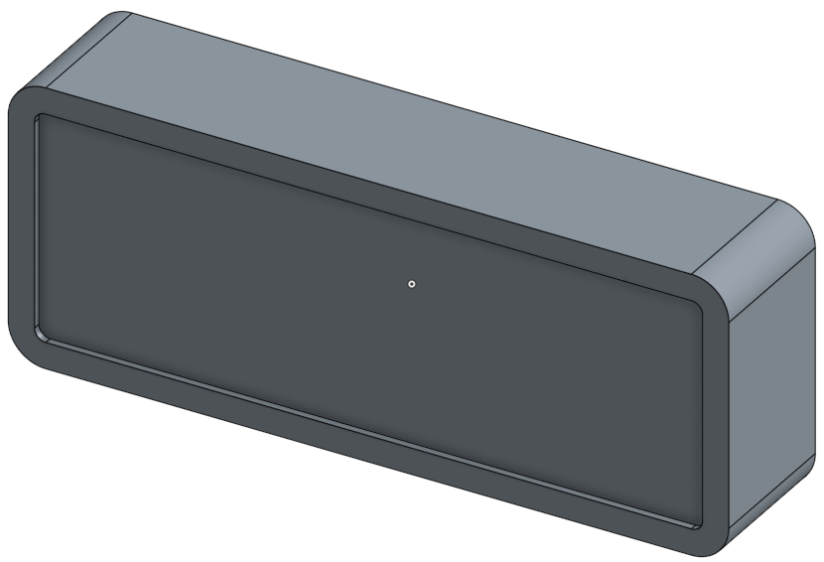

1. Next, use the same sketch to create a new part. Use the “Up to Face” option and select the inset face of the Frame. The name of this new part is Face. This is the front Face (or Bezel) of the speaker assembly.

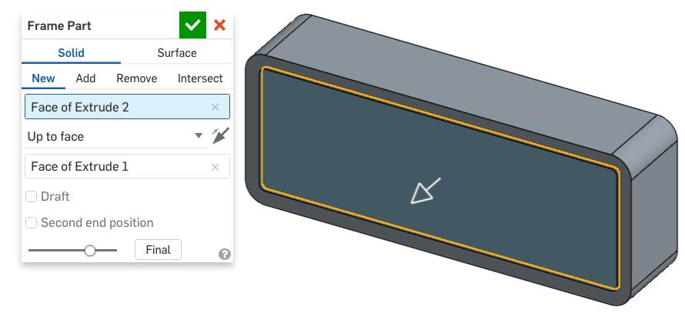

## Organizing the Feature List: Renaming Features

*Pro Tip: Up until now, most of our geometry workflow has been Sketch>extrude, sketch>extrude, sketch>extrude, etc. When this occurs, the feature tree is nice and organized, as each sketch is given a name, and the extrude is also given a name, and when created in order, the names are similar. Right now, the Feature Tree of our Bluetooth speaker should look like the picture on the left:*

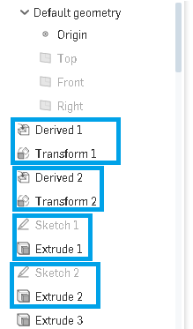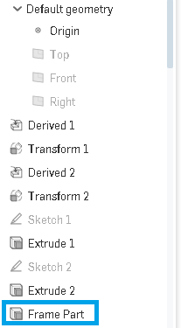

*Notice how the Derived and Transform features are both numbered the same (1 then 2), and same with the sketches and extrudes. It is easy to go back and see how it was built this way. However, now that we have reused a sketch to create a new part (the Speaker Face), our feature list loses the pattern. In fact, as we build this model (and more complex models) this pattern will completely go away. To stay organized, we can rename the features by right clicking, then “Rename”. Let’s rename the new feature to “Frame Part” (shown above on the right) so we know that this is the extrude feature that created the new Frame part.*

*Renaming features is a quick and easy way to stay organized. Renaming every single feature is not necessary (or recommended, unless it is a company policy). It is up to you as a designer to decide when it is worth the extra time, and when it is most beneficial. Just think, “Is there a pattern to the feature list? Could somebody else decipher my modeling process easily?” If the answer is no, then renaming the features will help. It’s similar to commenting your code as a software developer.*

1. Let’s hide that part for now (we’ll get back to it later). Create a new sketch on the front (indented) surface of our Frame (*not* the Front Plane). It should be a rounded square centered around the origin (to align with our Large Speaker):

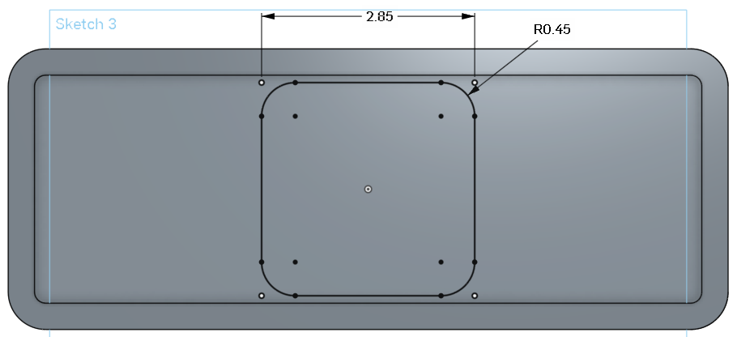

1. Now, let’s use this to remove material into the Frame. It should be 0.15 in deep, and have 25 degrees of draft. Make sure the draft is in the right direction (there should be no undercut surfaces):

*Pro Tip: As we’ve been learning throughout this curriculum, an extrude feature takes a 2-D sketch, and extrudes it outwards in such a way that the sides of the extrusion are always perpendicular to the sketch plane. Sometimes, that may not be desired, and for that we have the option to add “draft” to the feature. Draft is specified as an angle between the sketch plane and the extrusion direction. Having no draft is the same has having draft of 0 degrees. In this case, we are adding a draft just for looks, but we will soon learn how draft is an integral part of many manufacturing processes, and is specifically added to some features for that reason.*

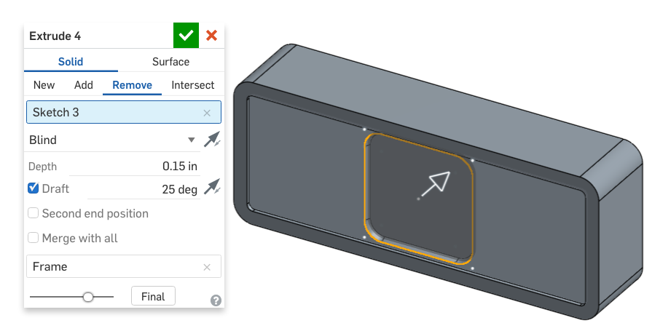

1. Next, let’s create similar geometry for our Small Speaker, again the square should be blue, since it is not located yet. This is okay:

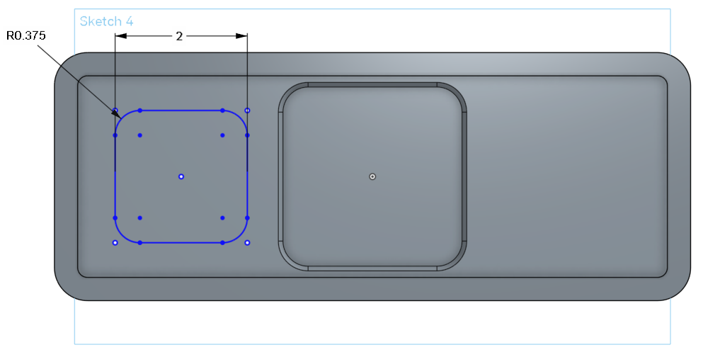

1. Let’s locate our square using the circle from the first sketch. Unhide Sketch 1, and create a Coincident constraint between the center of the circle and the center of our square. It should lock in place, and turn black. Accept the sketch:

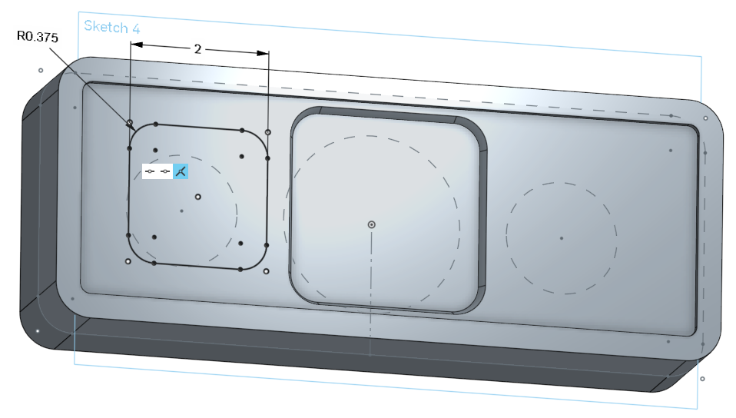

1. Just as before, let’s use this sketch to remove material, and add draft:

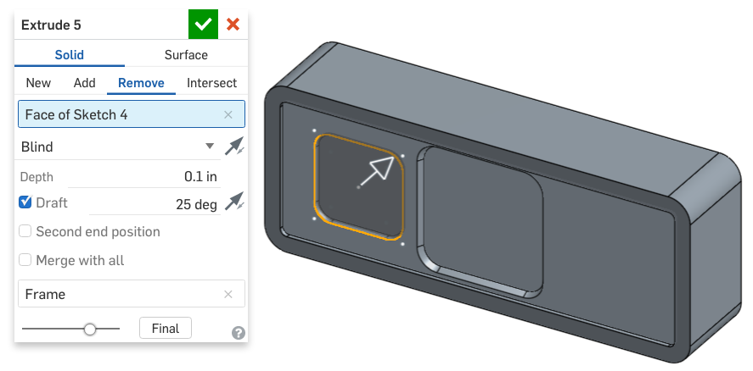

1. Now, let’s mirror this new feature across the Right Plane, for the other speaker:

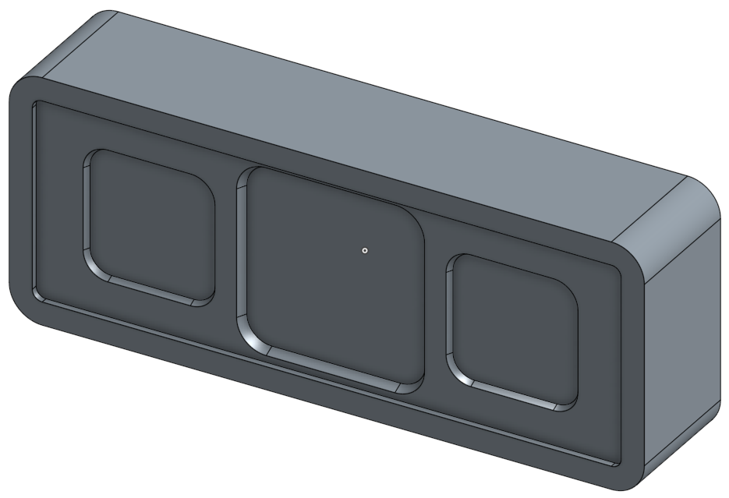

|  |
| --- |
| **Design Intent Check**: Let’s take a look at the bottom of the Frame. Take note of the many sketches that are involved. |

1. Now that we have the overall Frame shape defined, let’s focus on the bottom side of the bluetooth speaker, where we will house the batteries and design a stand. Here is a picture of what we are going to sketch and extrude. Make sure to include the construction line in the middle. We will be referencing this line in week 8:

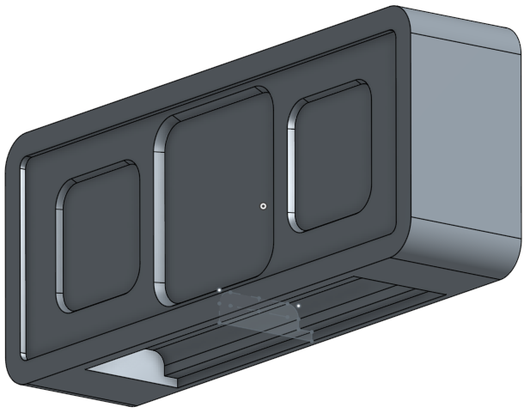

1. Start by creating the following sketch on the Right Plane. The outer dimensions (0.2, 0.125, 0.365, 0.14) are dimensioned from the outer faces of the Frame Part. Name this sketch “Battery Compartment Sketch”:

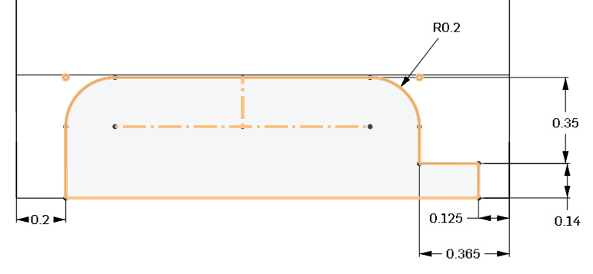

*Pro Tip: Notice in the graphic above, the visualization has been changed from Shaded, to Hidden Edges Visible. This is helpful, when you are sketching in the middle of a part like this. It’s a little easier on the eyes, and it’s may also show some lines in the part that we would want to use for dimensions or constraints. Below is a comparison of Shaded with Edges (Left), Translucent (Center), and Hidden Edges Visible (Right).*

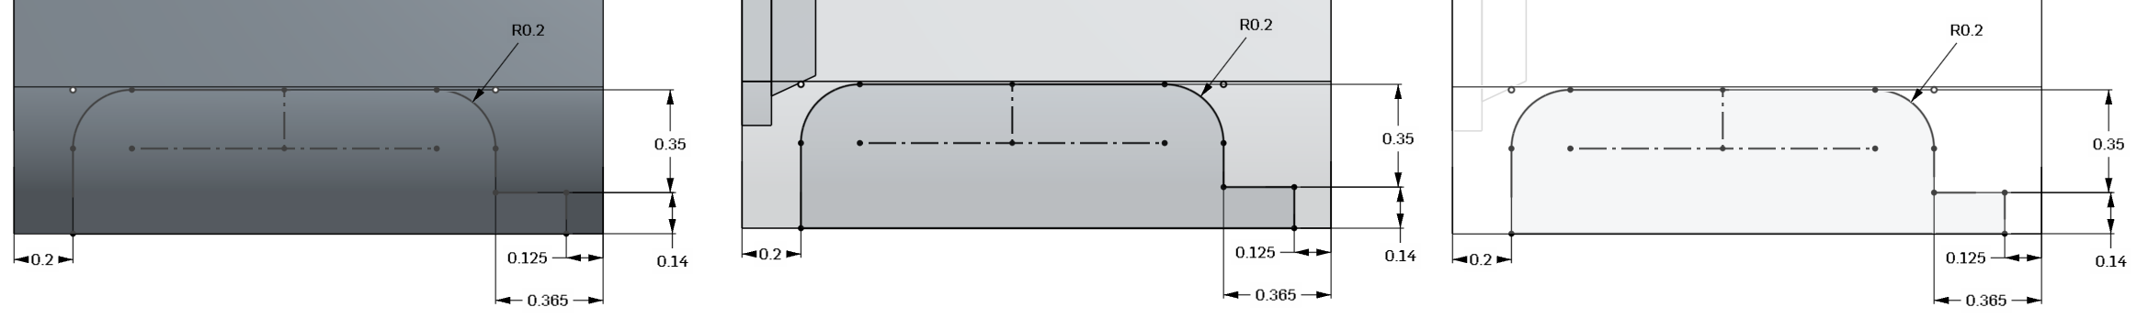

*Remember, the visibility tools are not only there to help see the finished product, but to help us create our geometry as well. Small things like this will make sketching in Onshape faster and easier.*

1. Use the sketch to remove 6.375 in of material symmetrically about the Right Plane. This is for the batteries:

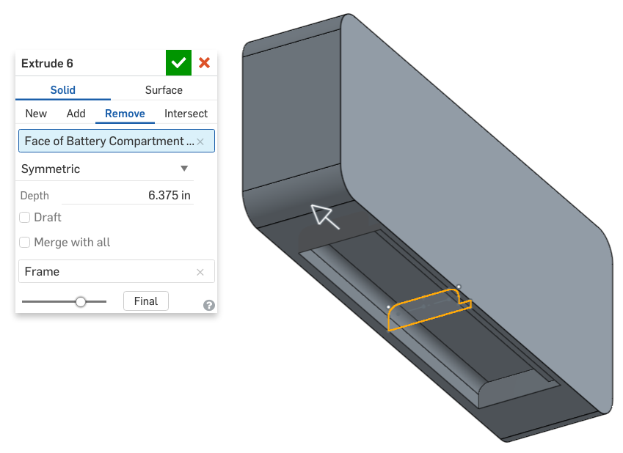

1. Now, let’s add a relief on each side for the battery cover. Note that the sketch is symmetric (the construction line is used to mirror the sketch), and pay attention to the sketch plane, which is highlighted in orange:

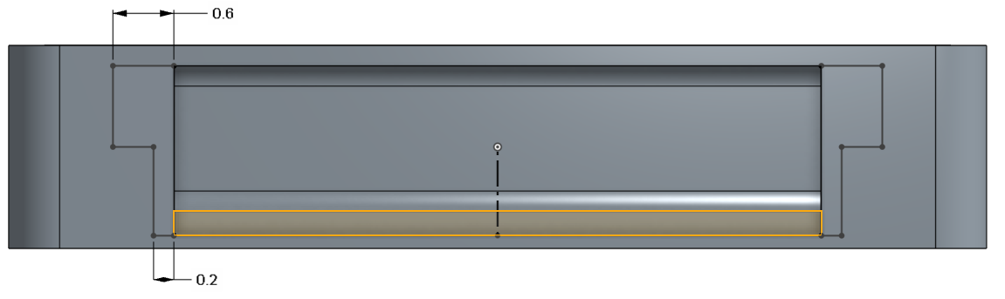

1. Using that sketch, remove material outwards Through All:

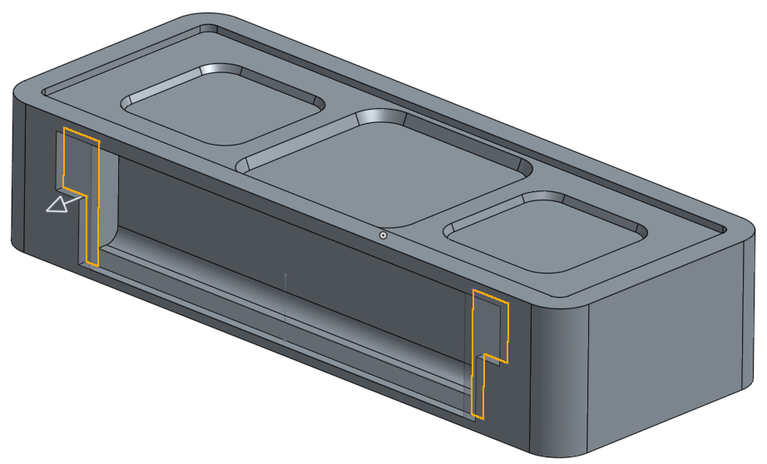

1. Next, using the most recent geometry as a reference, sketch two pockets on each side of the part:

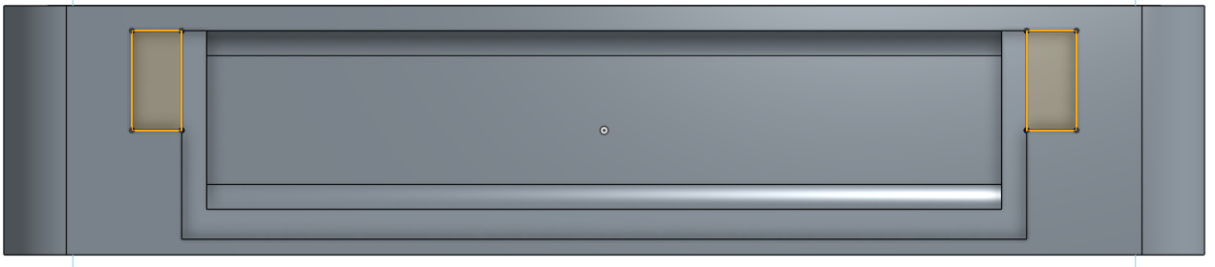

1. And remove material up to the bottom face of the battery opening:

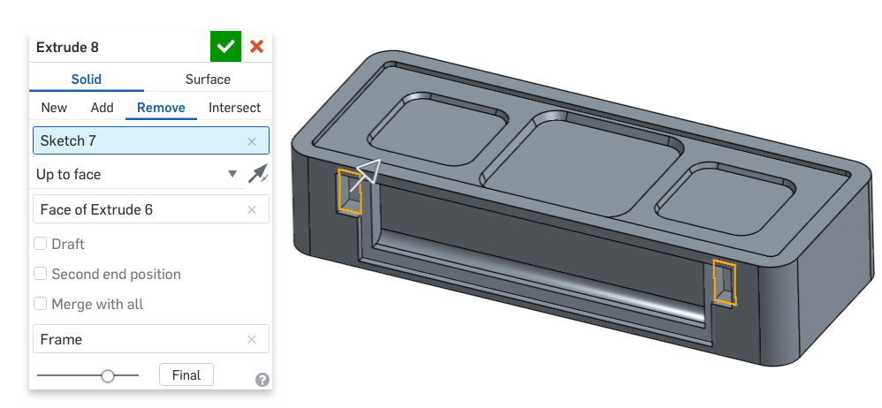

1. With the major geometry of the Frame built, we can now shell the part. Referencing the back face, create a 0.14 in shell. Imagine trying to do the job of Shell with just Extrudes!:

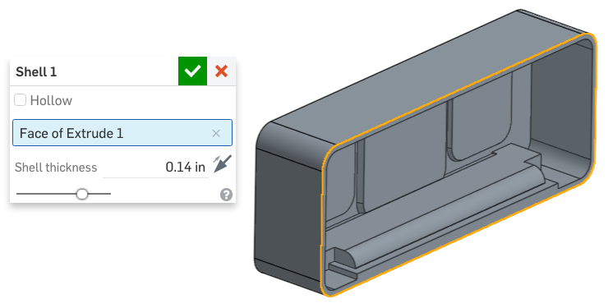

1. Next, let’s create holes for the stand hinge. Sketch a hole on the inside surface of the stand opening:

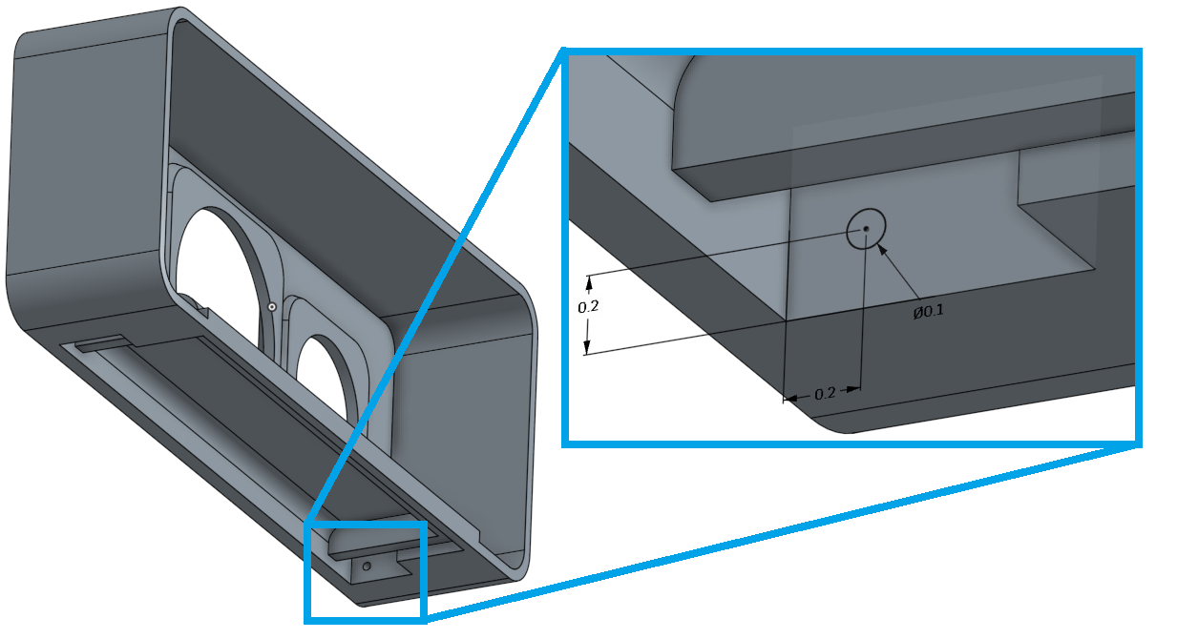

1. And extrude the hole “Up to next”:

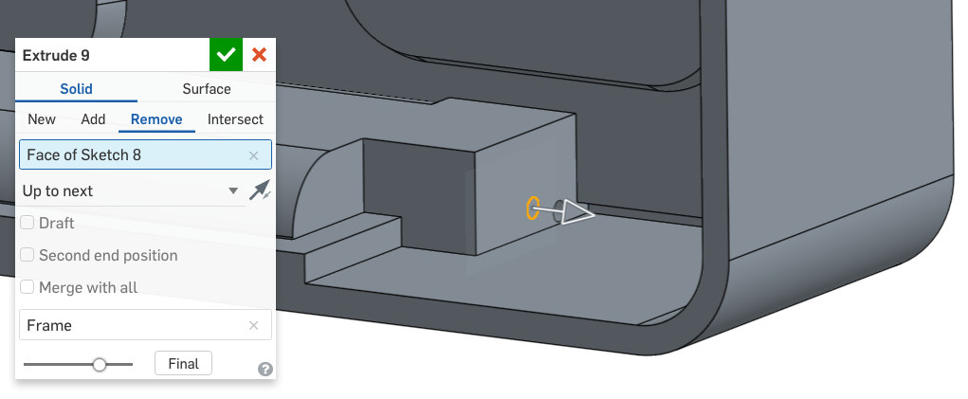

*Pro Tip: This is the first time we have used the “Up to next” depth option for an extrude. As you can see here, the hole goes down to the next face and stops, instead of going through the entire part. We could have created the same geometry other ways (with a blind depth, and typing in the number, or using Up to surface, and selecting the surface) but in this case, we minimize the amount of input to the feature. Any time we can have Onshape calculate the solution, instead having of us type values, or select reference geometry, we are creating a stable model with robust design intent. Good job!*

1. Now, let’s create the same hole on the other side. The feature or face could be mirrored, but let’s try another method for fun. Create a new sketch on the opposite surface, and use the “Use” tool to Project the previous sketched circle onto the new sketch. The new sketch will be fully defined and need no dimensions:

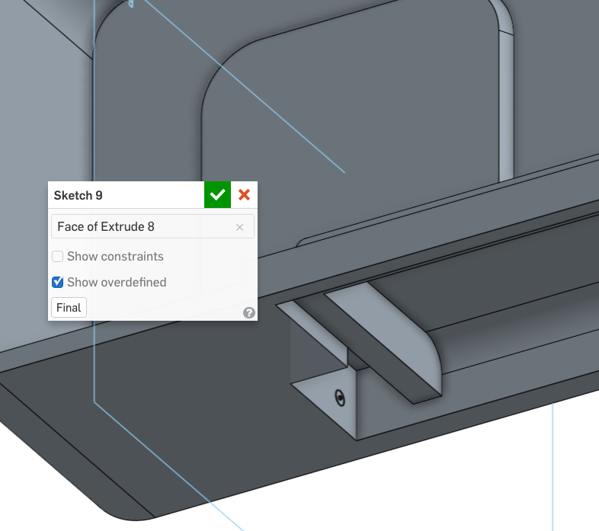

1. Same as before, this hole will be “Up to next”:

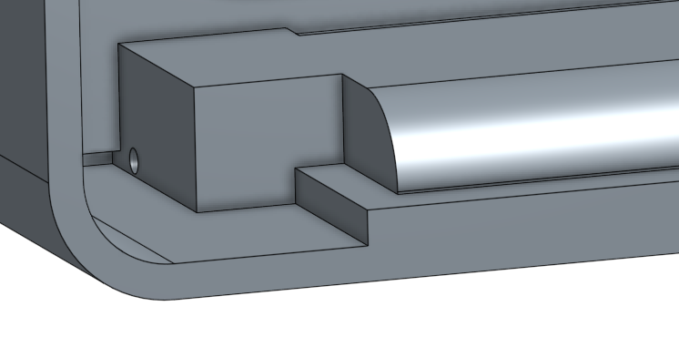

1. Next, we’ll add the holes for the speakers. For this, we will reference our original sketch, and we will extrude it in two directions. First, we will extrude it “through all” towards the front of the Frame part. However, notice that the center hole interferes with our battery opening. This is because the extrusion “starts” at the sketch plane:

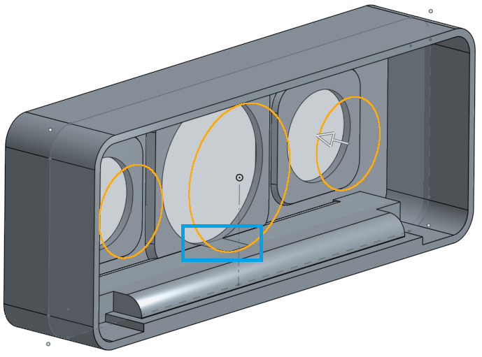

1. To alleviate this, we will move the “start” point of the extrude up to inside surface of the speaker opening. To do this, select the “Second end position” options. Choose “Up to face” and select the back face of the speaker opening (highlighted). Lastly, click on the direction arrow, to flip the second direction. Notice how the interference is gone! Also, since we are once again reusing a sketch, let’s take the time to rename our feature. In fact, we can rename our feature directly from the dialog box, just by clicking on the name, and typing in the new name. Let’s call this “Speaker Holes”. Click the Green checkmark:

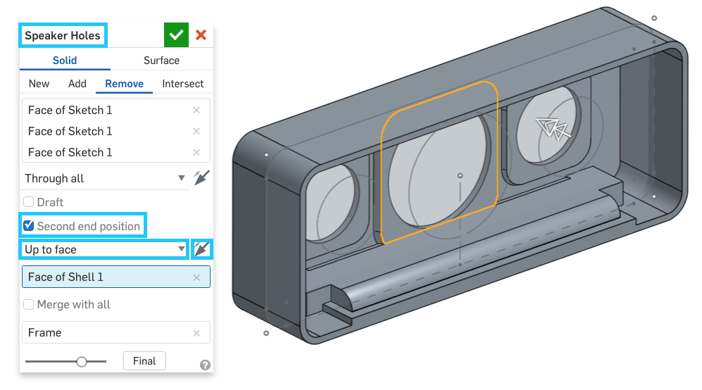

## Comments

*Pro Tip: When working in a team, it is important to communicate our design decisions amongst teammates. This not only helps document the design choices we make, but it also helps with “On the Job Training”, where we help teach our coworkers what we are doing and why. Comments are a way for us to add a note to our Onshape CAD model. They can be added to various items in Parts, Assemblies and Drawings. Anybody who the document is shared with (anybody on our team, for example), can get notified, review, and even respond to comments. Let’s practice, by adding a comment to the previous feature.*

* 1. *Right-click on the “Speaker Holes” feature we just created, and select “Add comment..”:*

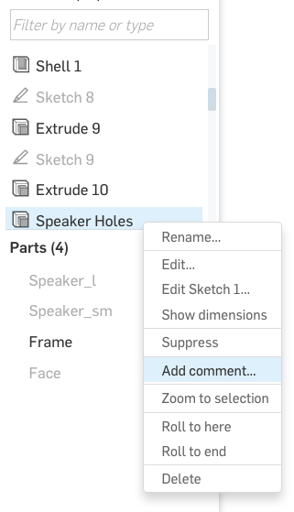

* 1. *The Comment flyout will appear in the Upper-Right corner of the screen. Let’s type the following note in there, “This feature has a second direction, to prevent interference with the battery compartment.”:*

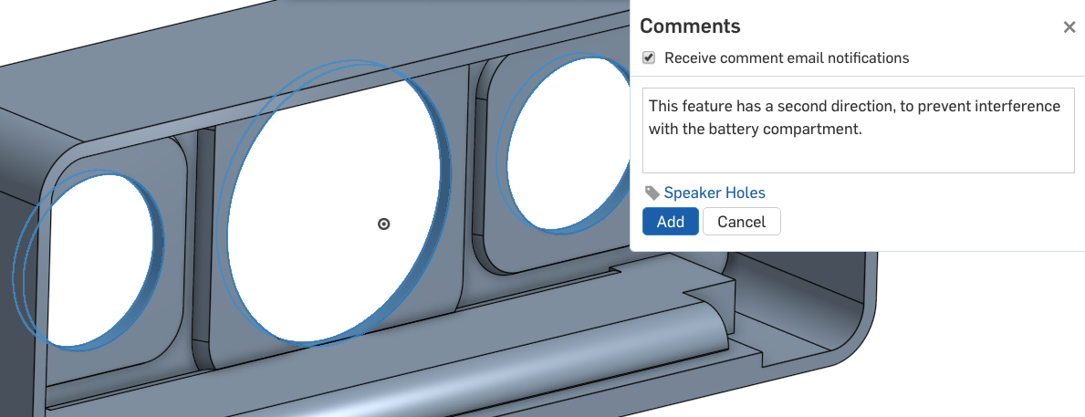

* 1. *Notice now that we have a new Comment icon next to this feature in the feature list:*

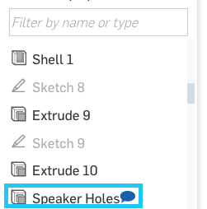

* 1. *Now, the Comment flyout can be closed to clean up the graphic screen. The comments can always be accessed by clicking on the comment icon in the top right-corner of the screen:*



*Whenever the comment flyout is opened, the comment icons will show in the feature list. And, whenever a reply or another comment is added to the document, you will be notified. For more information on comments, see the help here:* [*https://cad.onshape.com/help/#comments_on_workspaces.htm*](https://cad.onshape.com/help/#comments_on_workspaces.htm)

|  |
| --- |
| **Design Intent Check**: Finally, we’re going to make the button overlay. How does it interfere with the top of the Frame? |

1. Next, we are going to focus on the top part of the Bluetooth Speaker, where the buttons go. Our design includes a soft rubber overlay that covers the buttons, for a nice resilient feel. Let’s start by sketching the profile of the rubber overlay on the top of the Frame. The insert is centered about the origin, so we have used a construction line for creating constraints:

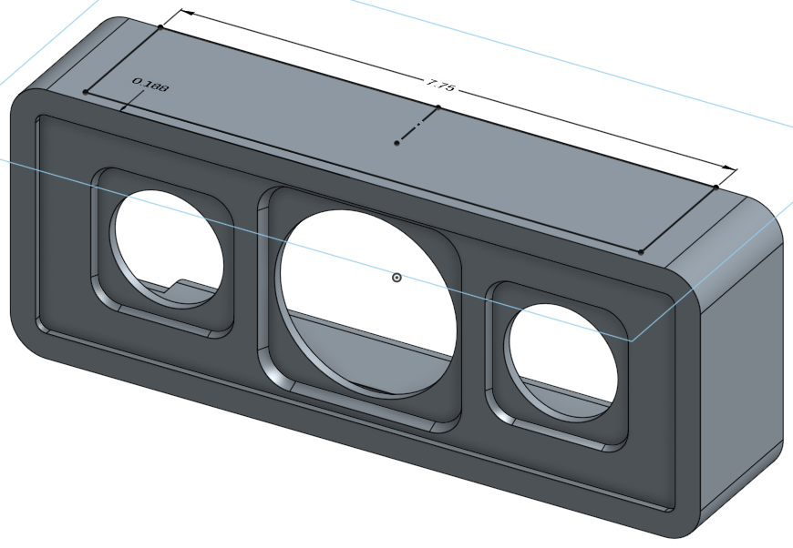

1. Extrude the profile downwards, and create a new part. Let’s call the new part the “Button Overlay”:

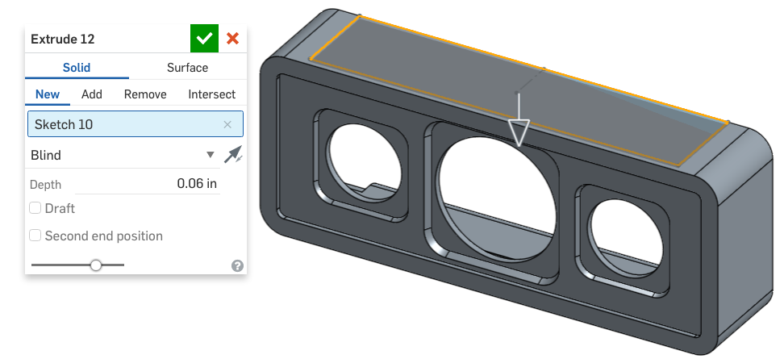

1. Hide the Frame part for clarity, and reorient to the “Top View” using the view cube, as shown below. On the bottom side of the Overlay, sketch the circles for the buttons, again taking advantage of symmetry by using the sketch mirror tool.:

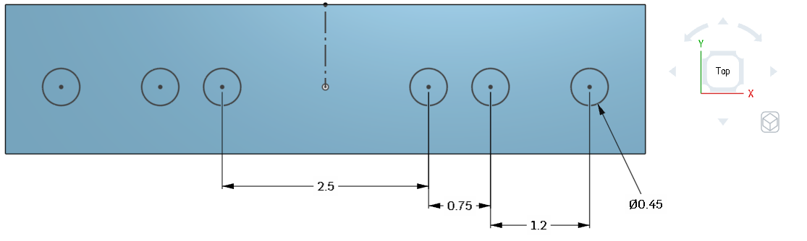

1. Now, extrude the buttons 0.1 in downwards. Make sure the extrude is added to the Button Overlay part:

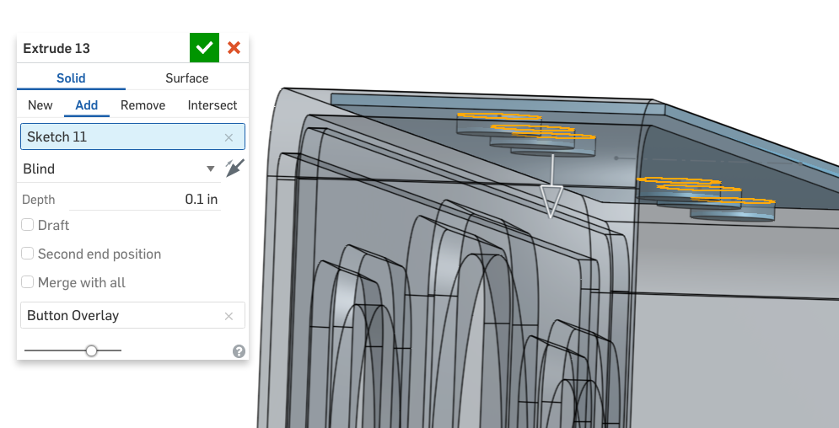

1. Next, let’s add a 0.075 X 0.075 chamfer to the base of all of the buttons:

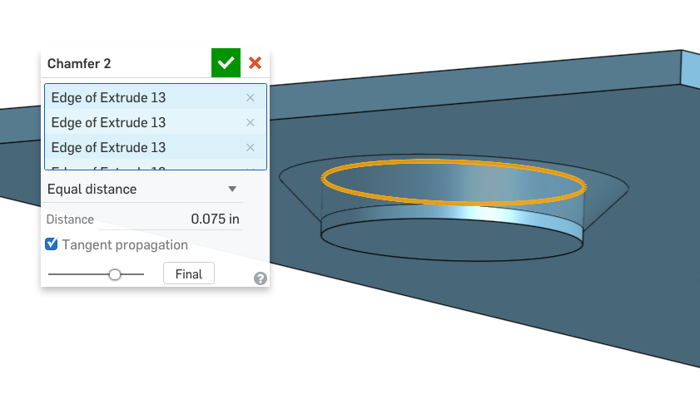

1. Now, let’s create the LED light overlay. Start by viewing the Button Overlay in the “Bottom” orientation, and create the following sketch on the bottom surface of the part. There is a “T” shaped pair of lines that are used to center the rectangle between the existing buttons:

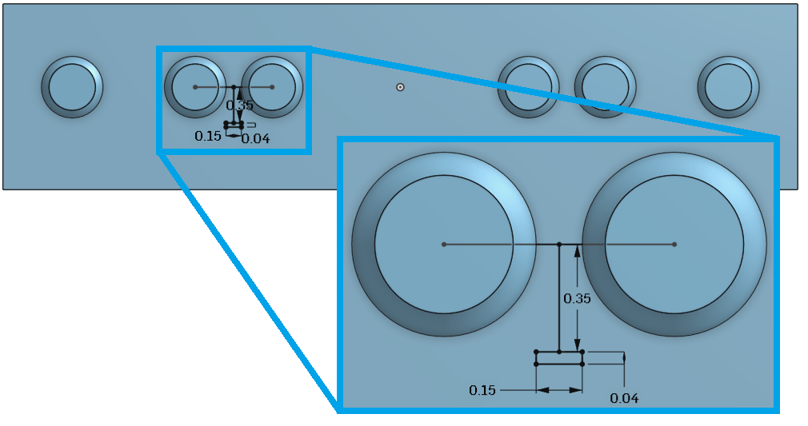

1. Now extrude the LED Overlay the same depth as the buttons (Hint: use the “Up to face” depth option). Note the orientation of the part below ,and make sure the LED overlay is in the proper location:

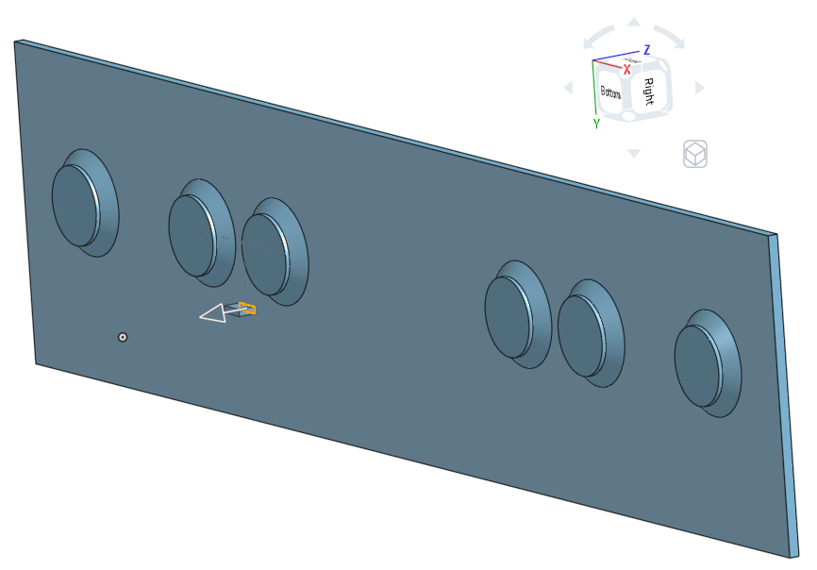

1. Now, we will create the rest of the LED overlays using a linear pattern. Use the edge of the part for the direction, and create a 0.25” pitch pattern in both directions:

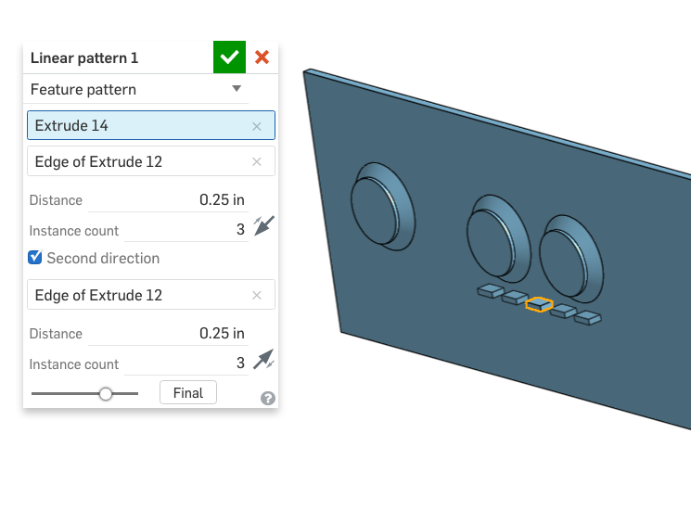

1. Next, we will create the lip in the rubber overlay that is used to position it on the Frame. Create the following sketch on the bottom of the Button Overlay part. Note that there are two offsets here; one offset from the outside of the part, and another offset from that one. Keep an eye on the direction of the offsets! Use equals constraints so that only 1 radius dimension is needed for all 8 radii:

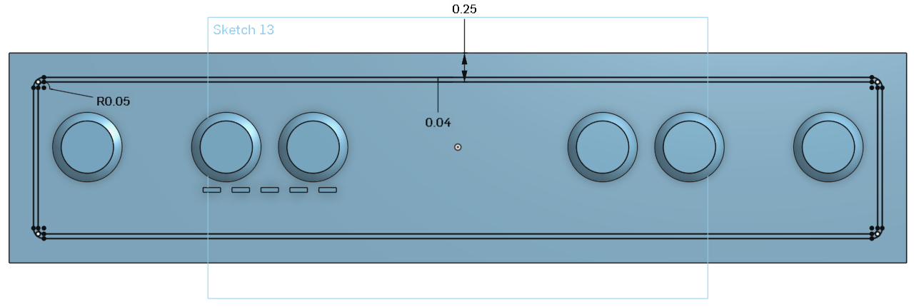

1. Next, extrude the lip .05 inches (commonly referred to as “fifty thousandths” or just “fifty thou”) downwards, making sure it is added to the Button Overlay part:

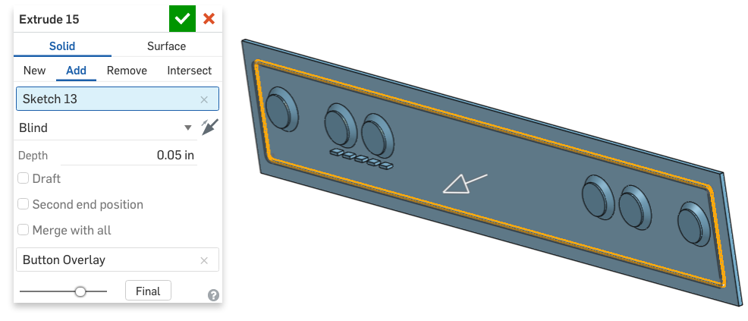

1. Next we are going to use all of this geometry that we just created in the Button overlay to remove material from the Frame using the Boolean Subtract tool, . In the dialog box, use the Button Overlay as the “Tool”, and the Frame as the “Target”. However, before we accept, check the “Offset” option, and select all vertical surfaces of the button overlays (highlighted below) and the LED overlays, and create a 0.01 offset. Make sure to “Keep tools”:

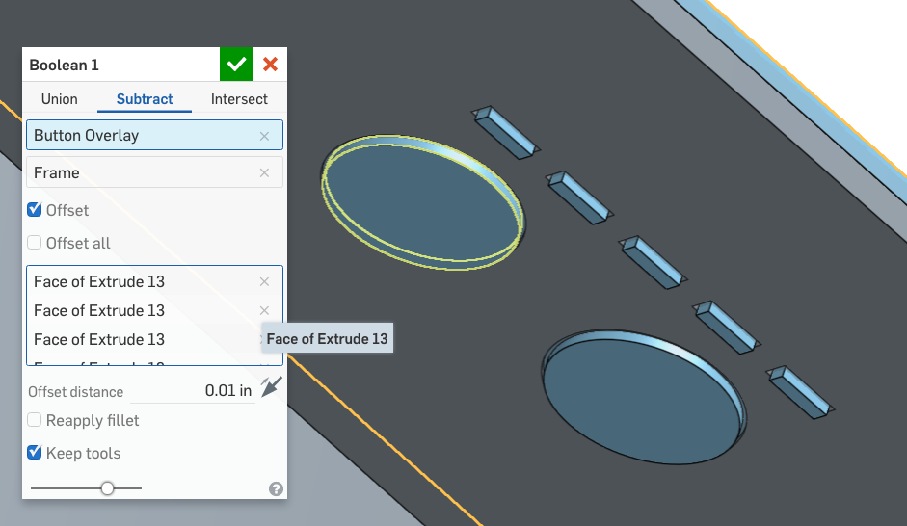

*Pro Tip: What did we just do? Well, we just included an offset to the boolean subtract. This creates a gap between the parts. This gap will allow the lip in the Rubber Overlay to fit snugly into the frame, but without having the button and LED overlays interfere. This is important, because without this gap, it would be very difficult to install the Rubber Overlay, due to manufacturing tolerances.*

*Below is a section view of the button and LED overlays, showing the results of the Boolean Subtract. The black rectangles show the gaps between the vertical surfaces of the Button and LED Overlays. The red rectangle shows the snug fit (no offset) of the lip.*

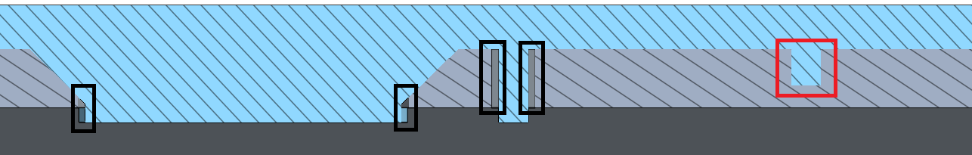

1. Let’s add another comment to this model for future reference. In this case, instead of attaching it to a feature, let’s attach it directly to geometry. Hide the Rubber Overlay, and view the Frame from the top. Click several of the newly created faces, Right-Click and select “Add Comment”:

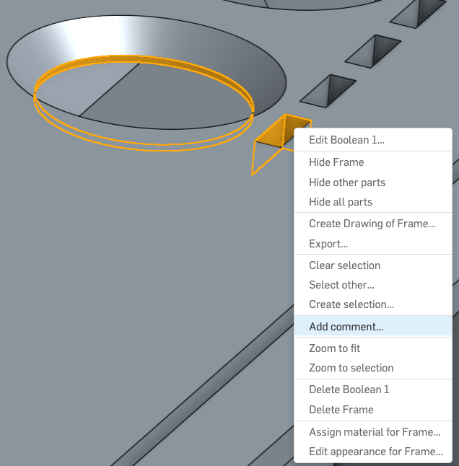

1. Now, let’s type in our comment, “These faces have been offset to account for manufacturing tolerances.”. Note that the comment icon is now in the graphics screen, instead of the feature list. Now, whenever that comment is clicked, the screen will automatically re-orient to the view that was shown when the comment was created. Try it!:

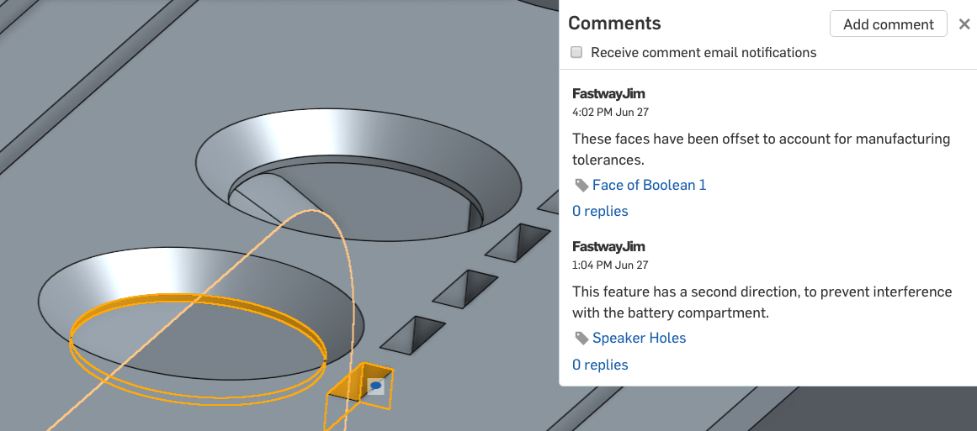

1. Next, we will reuse the button sketch to create the finger indents on top of the buttons. Extrude the circles upwards to remove material, and add 45 degrees of draft:

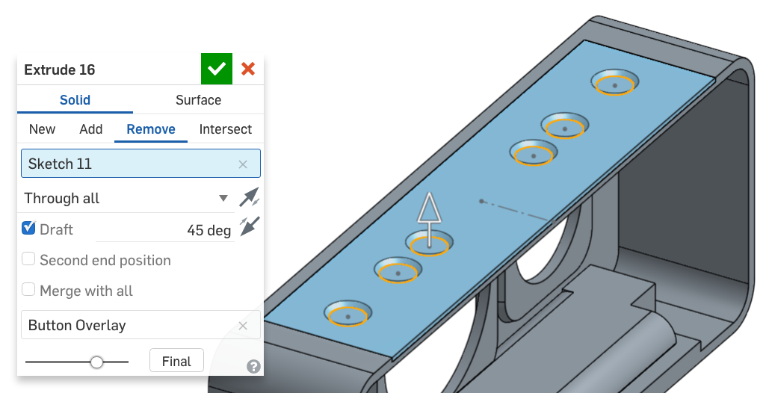

1. Next, let’s add a 0.5 in fillet to the top surfaces of the buttons:

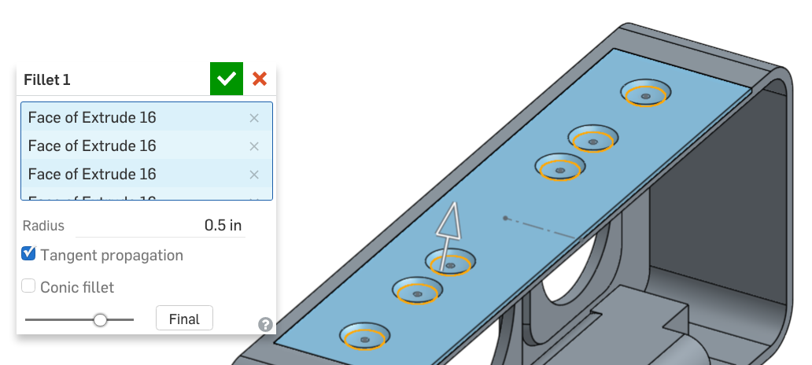

1. And finally, we’ll add a 0.1in fillet to the top edge of the buttons:

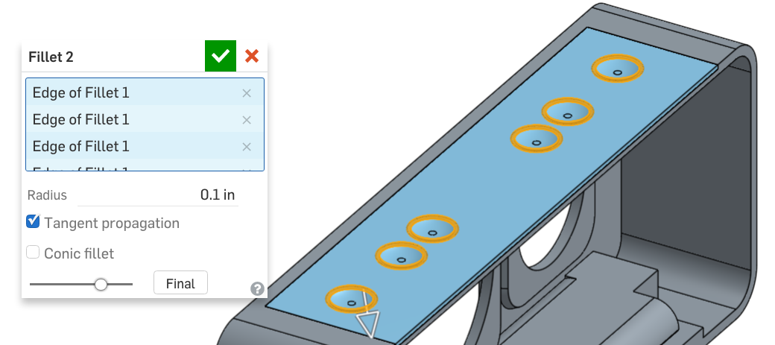

## Real Time Collaboration

Since the Onshape platform is 100% in the cloud, everything that occurs is live, and this facilitates what Onshape calls “Simultaneous Editing”, which occurs when two different people are working on the same document at the same time. Let’s say, for example, that we had trouble with the last feature. Your colleague/peer, on the other hand, has figured it out. Let’s work together to learn from each other:

1. Let’s start by navigating to the part and opening it from our Documents Page - we can find it easily by selecting the team name on the left hand side. Once the document opens, it will look perfectly normal. The difference here is that there is another user with looking at this document at the same time! You can tell this is happening if there is an icon in the upper right corner with a letter that represents the other person (or multiple people). For example, below we see a Purple “F” because our colleague Frankie has this document open. For the rest of this lesson, we will be collaborating with Frankie in real time:



1. Now that we are simultaneously editing the document, let’s have Frankie show us what they did with the previous feature. First, she will double-click the feature to edit it. When this happens, we can actually see her editing the feature, as it highlights with her icon:

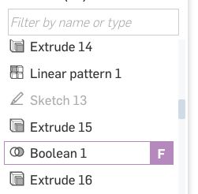

1. This is really helpful, especially when we have a large complex design, and we have multiple people working on it at the same time. Once our teammates are done editing the feature, the model is automatically updated with their changes in real time.

## Follow

1. Now, let’s have Frankie show us what she did. To do this, we are going to “follow” her, by watching her screen live. To do this, double-click on her icon in the upper-right hand corner of the screen. Once this occurs, your screen will highlight with a colorful border, and you will be able to see Frankie’s screen live!:

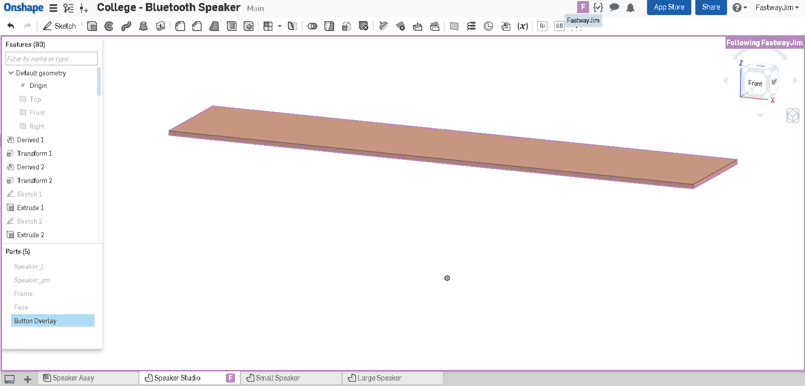

1. This will have to be tried to be truly experienced. To learn more about it, and to see a video of it in action, go here: <https://cad.onshape.com/help/#realtimecollaboration.htm>

Congratulations! This completes the first part of the Bluetooth Speaker Project. By now your geometry should look like this:

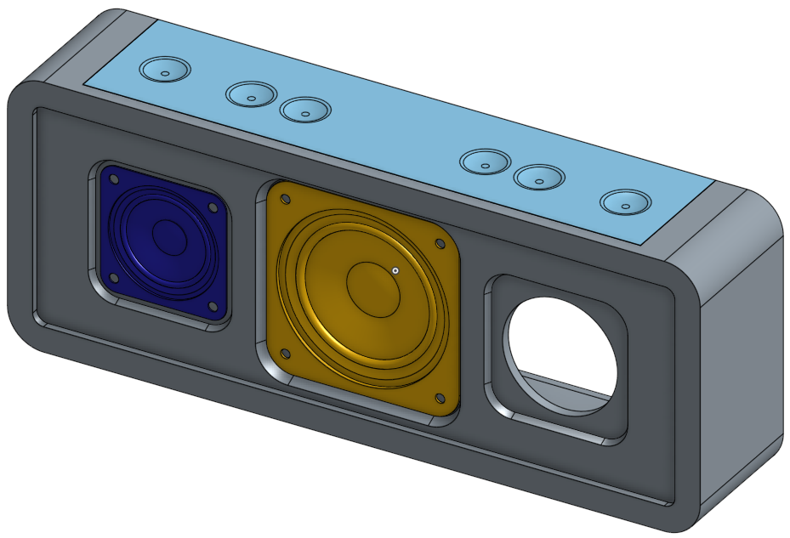

Here’s how our speaker looks like in the back with all the parts unhidden:

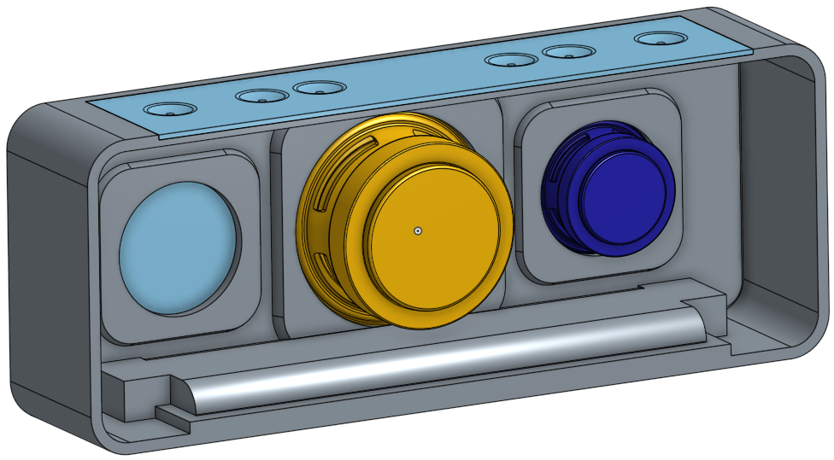

# Summary

Let’s take a second to reflect what we learned in this lesson.

1. We learned how to create and share documents to your team.
2. We learned how to transform derived parts.
3. We know that order in the Feature Tree matters, and learned how to move features around.
4. We can comment on specific parts of the Document.
5. We can simultaneously edit and follow collaborators when they’re making changes on your shared Document.

Great! Next week, we will continue with the Bluetooth Speaker project, adding more complex details to the Frame and creating Versions using Onshape’s version and history features.